**Przed równoważeniem:**

ipsweep (131), nmap (31), satan (190), normal (17428), smurf (154), pod (33), neptune (10450), portsweep (72), land (4), warezclient (162), buffer_overflow (11), loadmodule (2), back (204), phf (2), imap (2), guess_passwd (13), teardrop (186), warezmaster (4), rootkit (4), perl (2), ftp_write (1), multihop (1)

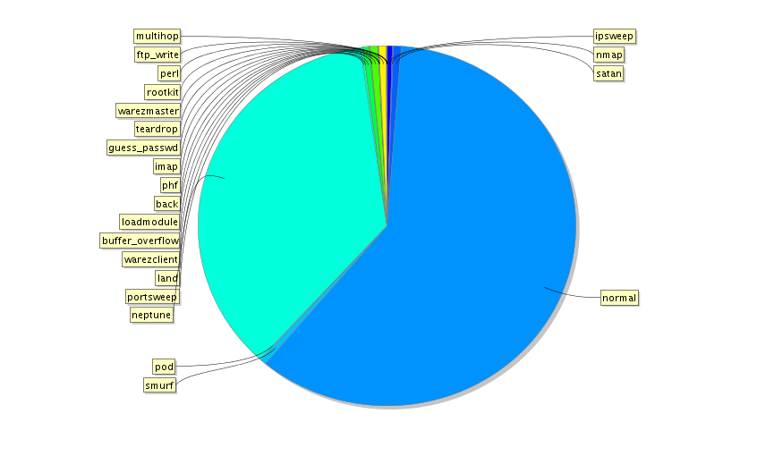

Mnożniki:

|  |  |  |  |  |
| --- | --- | --- | --- | --- |
|  |  |  |  | under do 200 |
| normal | 17428 | over |  | 87,14 |
|  |  |  |  |  |
| ipsweep | 131 | 133,0382 |  |  |
| nmap | 31 | 562,1935 |  |  |
| satan | 190 | 91,72632 |  |  |
| smurf | 154 | 113,1688 |  |  |
| pod | 33 | 528,1212 |  |  |
| neptune | 10450 | 1,667751 |  | 52,25 |
| portsweep | 72 | 242,0556 |  |  |
| land | 4 | 4357 |  |  |
| warezclient | 162 | 107,5802 |  |  |
| buffer_overflow | 11 | 1584,364 |  |  |
| loadmodule | 2 | 8714 |  |  |
| back | 204 | 85,43137 |  |  |
| phf | 2 | 8714 |  |  |
| imap | 2 | 8714 |  |  |
| guess_passwd | 13 | 1340,615 |  |  |
| teardrop | 186 | 93,69892 |  |  |
| warezmaster | 4 | 4357 |  |  |
| rootkit | 4 | 4357 |  |  |
| perl | 2 | 8714 |  |  |
| ftp_write | 1 | 17428 |  |  |
| multihop | 1 | 17428 |  |  |

Po oversampling:

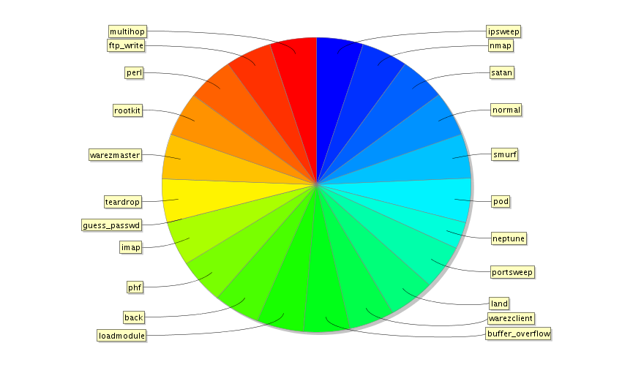

Po undersampling:

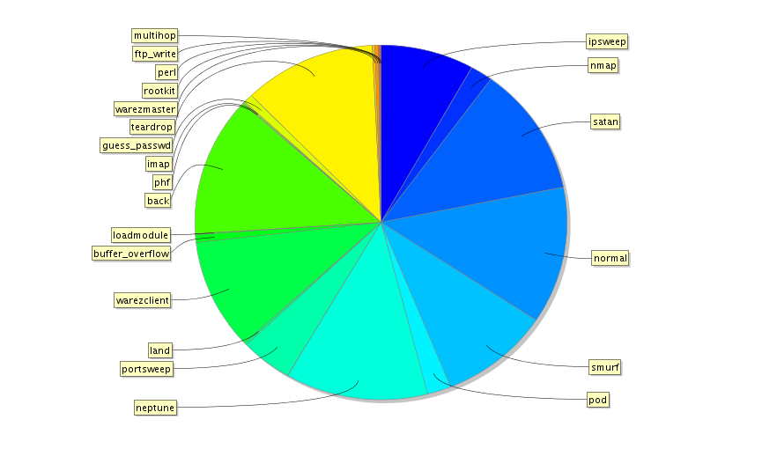

**Z podziałem na rodzaje ataków:**

Drzewa decyzyjne:

Bez równoważenia:

accuracy: 97.85%

Oversampling:

accuracy: 94.50%

Undersampling:

accuracy: 96.11%

Lasy losowe:

Oversampling:

accuracy: 0.56%

Undersampling:

accuracy: 85.36%

**Dla klas pozytywnej i negatywnej („jest atak” i „nie ma ataku”):**

Drzewa decyzyjne:

Bez równoważenia:

accuracy: 98.12%

Oversampling:

accuracy: 98.11%

Undersampling:

accuracy: 97.42%

Lasy losowe:

Oversampling:

accuracy: 36.21%

Undersampling:

accuracy: 82.02%